Bangladesh Army University of Engineering & Technology (BAUET)
Qadirabad Cantonment, Natore-6431


Proposal for Digital Logic Design Lab

On

Title of the Project

Submitted By: | Submitted To:
Mursheda Nusrat Della
Lecturer,
Dept. of ICE, BAUET
Student of Batch: | Department: ICE
Course Code: ICE 2116 | Credit Hours: 1.50
Course Title: Digital Logic Design Lab | Date of Submission:
Academic Semester: 2nd Year 1st Semester

Remarks

Date & Signature of Evaluator

Department of Information and Communication Engineering (ICE)

Table of Contents
- Introduction 3
- Literature Review 3
- Problem Statement 5
- Objectives 5
- Project Explanation 6
- Expected Outcome 8
- Milestone 9
- Budget 9
- Conclusion 10
- Reference List 10
- Declaration 11

Introduction
CashControl is a financial management platform designed to help users track their income, expenses, and overall financial health with ease. The app offers budget tracking, expense monitoring, and real- time financial insights, all through an intuitive user interface. Locally, the app uses MySQL for secure data storage, while when deployed, it utilizes Render for the backend, Vercel for the frontend, and Neon for database management.
The platform allows users to download or email their income and expense reports at any time, making it easy to track financial activities. With personalized financial suggestions, CashControl helps users make informed spending decisions. Whether managing monthly expenses or reviewing financial history, it simplifies personal finance management for all users.
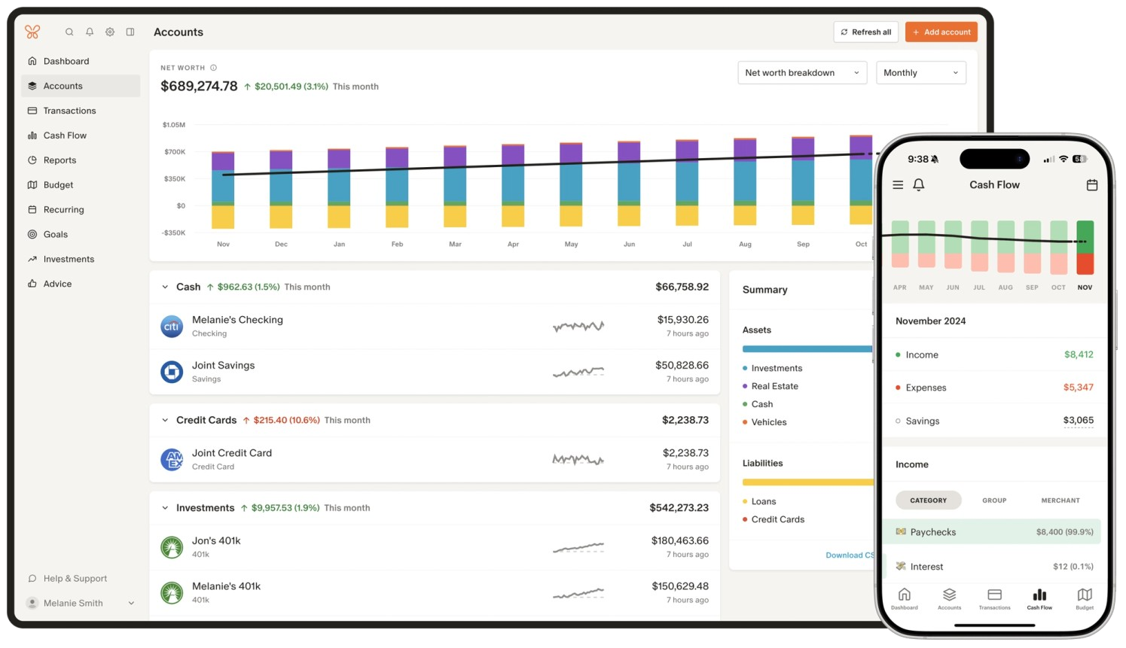

Figure 1: Overview of Cash Control App

Literature Review
  - Efficiency:CashControl ensures efficiency with MySQL for data storage, Render for backend hosting, Vercel for frontend delivery, and Neon for database management. These technologies provide fast, scalable performance and smooth real-time updates for users.

Significance:

CashControl simplifies personal finance management, offering real-time income and expense tracking, budget management, and financial insights. It helps users make better financial decisions and gain control over their finances.

Advantages:

    - Easy-to-Use Interface for simple financial tracking.

    - Real-Time Updates on financial data.

    - Email & Download Reports for easy access.

    - Simple Budgeting to manage income and expenses effectively.

Related Works & App Reviews:

    - Mint: Offers budgeting and expense tracking, but struggles with bank syncing issues.

    - YNAB: Focuses on zero-based budgeting but has a steep learning curve and is paid.

    - Personal Capital: Includes investment tracking but can be overwhelming for basic users.

    - Money Manager: Great for simple expense tracking but lacks advanced features.

    - PocketGuard: Offers simple budget tracking but lacks detailed reports or forecasting.

CashControl stands out with its easy interface, focus on local currency (using tk symbol), and simplified financial management for users in Bangladesh.

Limitations:

    - Limited Features: CashControl focuses on income and expense management, without advanced features like investment or tax planning.
    - Cloud Dependence: While cloud-based services like Render and Neon offer scalability, the app's performance could be impacted by potential service disruptions.

Features:

    - Income & Expense Tracking: Detailed logging and real-time updates for all financial transactions.
    - Real-Time Insights: Immediate feedback on spending and budgeting.

    - Download & Email Reports: Conveniently download or email financial data.

Problem Statement

Managing personal finances remains a challenge, especially in emerging markets like Bangladesh, where existing financial apps lack localization and fail to address specific user needs. While apps like Mint and YNAB provide general solutions for budgeting and expense tracking, they don't support local currencies (like tk symbol) or real-time transaction syncing, and often come with a complex interface or subscription costs.
CashControl aims to bridge this gap by providing a simple, cost-effective platform tailored to Bangladesh. Using a cost-effective framework, the app offers essential features such as real-time transaction syncing, local currency support (tk symbol), and downloadable or email-able financial reports. Additionally, future enhancements will include AI-driven financial suggestions and multi-currency support for broader regional access.

Objectives:
  - To develop a localized financial management platform with tk symbol support for Bangladeshi users.

  - To enable real-time transaction syncing with local banks and payment providers.

  - To provide simple and efficient budgeting tools for easy budget management.

  - To offer downloadable and email-able reports for convenient access to financial data.

  - To maintain a cost-effective solution offering essential features for free and a freemium model for advanced features.

  - To ensure scalability and security for smooth user growth and data protection.Future Improvements

  - To enhance user experience through AI-driven financial suggestions for better spending and savings.
  - To integrate multi-currency support for users across South Asia, expanding the platform's reach.

Project Explanation:

Star

Critical Analysis: CashControl fills the gap by offering a simple, localized financial solution for Bangladesh, with future plans for AI suggestions and multi-currency support to enhance its usability.

Literature Review: CashControl is a financial management app for Bangladesh, using Spring Boot for backend, React and Tailwind CSS for frontend, and WebStorm for development. It offers real-time syncing, budgeting tools, and downloadable reports, tailored for local currency (tk symbol).

Requirements:
Backend: Spring Boot, etc.
Frontend: React + Tailwind CSS,etc.
Database: Neon. IDE: WebStorm. Email: BrevoSend.

Objectives:
- To offer a localized financial solution with real-time syncing and budgeting tools.
- To ensure seamless integration of backend and frontend for efficient user experience.

NOT OK
OK

Features:
- Income & Expense Tracking: Log and manage income and expenses.
- Budgeting Tools: Set and track budgets.
- Downloadable/Email-able Reports: Export financial reports easily.
- Localized Currency: Supports tk symbol for Bangladesh.
- Simple UI: Easy-to-use interface for all users.

Project Setup:
- IDE Usage:
  - IntelliJ IDEA: Used for backend development with Spring Boot for managing the backend logic and APIs.
  - WebStorm: IDE: Use WebStorm for frontend React development.
- Local Database Setup:
  - MySQL: Used locally to store income, expense, and financial data during development.
- Deployment Setup:
  - Neon: Used for database management in the deployed environment.
  - Vercel: Used for deploying the frontend (React + Tailwind CSS) to production.
OK
Testing
NOT OK

End

Backend:
- Use pagination and caching.
- Run tasks in the background.
- Load balance traffic.

Frontend:
- Lazy load components.
- Minify and optimize code.
- Compress images.

API:
- Use rate limiting and compression.
- Cache responses.

Security:
- Use HTTPS and JWT tokens.

Expected Outcome

CashControl is a financial management platform that focuses on income and expense tracking. The Income and Expense pages show transactions for the current month, while the Filter page allows users to view the previous month's transactions. Future month transactions cannot be added.

The Dashboard features a visually appealing pie chart summarizing income and expenses, while detailed graphs show income and expense trends. The platform provides a simple and beautiful way to track and analyze your finances.

Milestone
The Graph chart of proposed project is following (Example):
Tasks |  | Project Duration (6 Months)
 |  | Semester-1 (Before Mid-term Exam) |  |  |  |  |  | Semester-1(After Mid-term Exam)
 |  | weak 1 | Weak 2 | weak 3 | weak 4 | weak 5 | weak 6 | weak 7 | weak 8 | weak 9 | weak 10 | weak 11 | weak 12
1 | Task 1
2 | Task 2
3 | Task 3
4 | Task 4
5 | Task 5
6 | Task 6
7 | Task 7
8 | Task 8
9 | Task 9
10 | Task 10

Task | Description
Task 1 | Backend Development (Spring Boot)
Task 2 | Database Design and Integration
Task 3 | Testing and Debugging (Backend)
Task 4 | Frontend Development (React + Tailwind CSS)
Task 5 | Dashboard and Visual Elements
Task 6 | Frontend-Backend Integration
Task 7 | Filter Implementation for Previous Month
Task 8 | UI/UX Improvements and Refinements
Task 9 | Testing and Debugging (Frontend)
Task 10 | Deployment and Hosting

Budget
Category | Description | Estimated Cost
Development Tools | Software and tools used for coding and development. | $150/month = 18000tk
Backend Hosting (Render) | Cost for backend deployment on Render. | $100/month = 12000tk
Frontend Hosting (Vercel) | Cost for frontend deployment on Vercel. | $50/month = 6000tk

Database (Neon) | Database management on Neon (storage and usage). | $150/month = 18000tk
Design Tools | Tools for UI/UX design (e.g., Figma, Adobe). | $200/month = 24000tk
Cloud Storage (Cloudinary) | Cost for image and file storage on  Cloudinary. | $50/month = 6000tk
Email Service (BrevoSend) | Cost for email notifications via BrevoSend. | $75/month = 9000tk
Marketing & Promotion | Budget for app marketing and user acquisition. | $50/month = 6000tk
Postman for API Testing | Cost for Postman Pro. | $120/month = 14400tk
Total Estimated Cost | Total project cost estimate | $1,395 = 167400tk
In Word: one lakh sixty-seven thousand four hundred taka only.

Conclusion
In conclusion, the CashControl project effectively provides a robust financial management system for users, enabling them to track income, expenses, and monitor their financial health. The backend, built using Spring Boot and MySQL, ensures seamless handling of transactions and efficient data retrieval. The frontend, developed with React and Tailwind CSS, delivers an intuitive and user-friendly experience, with features like graphs, filters, and dynamic dashboards for clear financial insights. The integration of these components and deployment through Render and Vercel ensures the platform’s scalability and ease of use. The project's success lies in its clear structure, user-centered design, and smooth functionality, allowing individuals to maintain control over their finances effortlessly.

Reference List
- S. Johnson and P. Smith, "The Impact of Personal Finance Apps on Financial Literacy," Journal of Financial Education, vol. 45, no. 2, pp. 101-112, 2021.
- Mint, "Mint Personal Finance App," Mint.com. [Online]. Available: https://www.mint.com. [Accessed: Aug. 30, 2025].

- You Need A Budget, "You Need A Budget," YouNeedABudget.com. [Online]. Available: https://www.youneedabudget.com. [Accessed: Aug. 30, 2025].
- Personal Capital, "Personal Capital: Financial Planning," PersonalCapital.com. [Online]. Available: https://www.personalcapital.com. [Accessed: Aug. 30, 2025].
- Money Manager, "Money Manager: Personal Finance Tracker," MoneyManagerApp.com. [Online]. Available: https://www.moneymanagerapp.com. [Accessed: Aug. 30, 2025].
- PocketGuard, "PocketGuard: Budgeting and Expense Tracking," PocketGuard.com. [Online]. Available: https://www.pocketguard.com. [Accessed: Aug. 30, 2025].
- GoodBudget, "GoodBudget: Envelope Budgeting App," GoodBudget.com. [Online]. Available: https://www.goodbudget.com. [Accessed: Aug. 30, 2025].

Declaration
We are declaring that this proposal is original and not submitted anywhere else. To the best of our knowledge there is not conflict government and BAUET policy.
Signature & Date

Name of Student-

ID of Student-

